**NOVEL APPROACH FOR IMAGE ENHANCEMENT**

Project submitted to the

SRM University – AP, Andhra Pradesh

for the partial fulfillment of the requirements to award the degree of

**Bachelor of Technology**

In

**Computer Science and Engineering**

**School of Engineering and Sciences**

Submitted by

Likhitha Parvathi Tadikonda AP19110010006

Masoom Anas Khan AP19110010016

Yogitha Goli AP19110010320

Under the Guidance of

**Dr. Jatindra Kumar Dash**

**SRM University–AP**

**Neerukonda, Mangalagiri, Guntur**

**Andhra Pradesh – 522 240**

**[May, 2023]**

# Certificate

**Date :** 29 March 2023

This is to certify that the work present in this Project entitled “NOVEL **APPROACH FOR IMAGE ENHANCEMENT”** has been carried out by group of three which includes Likhitha Parvathi Tadikonda - AP19110010006, Masoom Anas Khan - AP19110010016, Yogitha Goli - AP19110010320under my supervision. The work is genuine, original, and suitable for submission to the SRM University – AP for the award of Bachelor of Technology/Master of Technology in **School of Engineering and Sciences**.

**Supervisor**

**Dr. Jatindra Kumar Dash**

Associate Professor & Head of the Department,

Department of Computer Science Engineering, SRM University–AP

# Acknowledgement

I am overwhelmed with a sense of gratitude towards individuals who have helped me in preparing the work that is allocated. On the site I would like to convey my regards to our guide **Dr. Jatindra Kumar Dash**, Associate **Professor & Head of the Department**, Department of Computer Science and Engineering, Batch (2019-2023), Bachelor of Technology, SRM University - AP. He is a constant source of encouragement and intellectual stimulation. This research has been carried out by a team of three that has included **Likhitha Parvathi Tadikonda - AP19110010006**, **Masoom Anas Khan - AP19110010016** and **Yogitha Goli - AP19110010320.**

My sincere gratitude to Associate Professor Dr. Jatindra Kumar Dash, Bachelor of Technology, Department of Computer Science and Engineering for giving me support and valuable insights and friendly advice during the project work to do this dissertation.

**PLACE:** Amaravati

**DATE:** 29 March 2023

# Table of Contents

Certificate 1

Acknowledgement 2

Table of Contents 3

Abstract 4

Abbreviations 6

List of Tables 7

List of Figures 8

1. Introduction 9

2. Literature Review 11

3. Discussion 13

3.1 DNA Net 13

3.2 Dense Nested Attention Network 13

3.2 Advantages & Disadvantages 14

4.Objectives of this Research/Methodology 16

4.1 Preprocessing using DNA Net 16

4.2 Feature Extraction Based on Sharpening 16

4.3 Predicting the targets 17

5. Results 18

6. Concluding Remarks 20

7. Future Work 21

References 22

# 

# Abstract

Enhancing small infrared targets in images is a challenging task due to their low contrast and limited spatial information. In this paper, we proposed a novel approach to specifically improve the performance of an already existing research paper [[1]](https://doi.org/10.3390/rs14133232) which is designed for the enhancement of small infrared targets, addressing the unique characteristics and requirements of such images.

We have aimed to improve the visual quality of an image by enhancing its details, contrast, and overall appearance. The proposed approach combines the power of traditional image processing techniques to improve the visibility and detectability of small infrared targets. Initially, a pre-processing step is performed through DNA Module to enhance the overall image quality and reduce noise. This includes denoising, contrast adjustment, and local adaptive filtering to enhance target details while preserving the background context. Then we used lanczos2 up-sampling for sharpening the spatial filter and lanczos interpolation.

We introduced Densely Attested Network (DNA) Module to preprocess and feed the input image to extract multi-layer features. To further enhance the small infrared targets, we employ a deep learning-based method. We develop a convolutional neural network (CNN) model to learn the specific patterns and features associated with low-quality images with small targets and the predicted masks for capturing complex relationships and patterns in the data. It is trained on a large dataset of annotated infrared images containing small targets, enabling it to effectively enhance their visibility.

We have implemented the Main base paper published by Liu S, Chen P, Woźniak M and achieved a mIOU of 75. The highest that had been achieved in the research area of Small Infrared Targets is 78. But, after introducing our algorithm it reached 71.1%. However, our algorithm enhances its edge pixel value and expands the pixels, thereby diminishing its similarity to the small target. Consequently, the algorithm becomes capable of detecting the small target without generating false positives, leading to a reduction in the false alarm rate.

In addition, we incorporate perceptual loss functions such as False Alarm Rate (Fa), Detection Rate (Pd) , Mean Intersection Over Union (mIoU) and Pixel Accuracy that measure the perceptual similarity between the generated images and the ground truth high-quality images. This helps ensure that the enhanced images not only exhibit enhanced details and contrast but also maintain their naturalness and visual fidelity.

Experimental results when compared to the base paper of our research demonstrate the effectiveness of our proposed approach. The images enhanced by our method exhibit significant improvements in terms of False Alarm Rate and Detection Rate compared to existing state-of-the-art methods. Furthermore, subjective evaluations from human observers confirm the superiority of our approach in producing visually pleasing and realistic enhancements.

Overall, the proposed novel approach for image enhancement combines the strengths of CNNs, DNAs, and perceptual loss functions to achieve noticeable results. This research contributes to the field of image processing by providing an effective and efficient solution for enhancing low-quality images, with potential applications in various domains such as surveillance, medical imaging, and digital photography.

**Keywords — Small Infrared Targets, Enhanced IR Target Detection, Convolutional neural networks (CNNs), Thermal Imaging Systems, Contrast adjustment, Image enhancement, Denoising.**

# Abbreviations

CNN Convolutional Neural Network

DNA Dense Nested Attention Network

Fa False Alarm Rate

Pd Detection Rate

mIoU Mean Intersection Over Union

Pix Acc Pixel Accuracy

# List of Tables

Table 1. Specific parameters used for DNA net.………………………………………..15

Table 2. Individual measures for NUAA-SIRST Dataset……………………...………..15

Table 3. Fa, Pd, mIOU, Pix Acc obtained by the different algorithms on the NUAA–SIRST dataset...………………………………………………………...…………………..18

# List of Figures

Figure 1. Raw Image, Ground Truth/Mask, Predicted……….…….…………………9

Figure 2. Sharpening spatial filter……………………………...………………...…….…10

Figure 3. Target pixels expand with up-sampling …….……………………….....……10

Figure 4. Dense Nested Attention Network………….……………..…………..………14

Figure 5. Raw Original Input Image……………………….…...………………….……16

Figure 6. Ground Truth / Given Masks……………...………………………….…...…17

Figure 7. Predicted Masks……………………………...……………………………...…17

Figure 8. Comparison of our algorithm with the existing algorithm from the base paper.……………...……………………………………………………………………..….18

Figure 9. mIoU for the proposed method with that of DNA Net.……………..……………………………………………………………………..…….19

# 1. Introduction

Infrared imaging technology plays a crucial role in various applications, including surveillance, target recognition, and autonomous systems. One of the significant challenges in infrared imaging is the detection of small targets in complex environments. These targets often suffer from low contrast, limited spatial resolution, and high levels of noise, making their identification and tracking difficult.

To address this issue, researchers have explored various image enhancement techniques to improve the visibility and detectability of small infrared targets. The objective is to enhance the target-to-background contrast while suppressing noise and mitigating the impact of adverse environmental conditions. The effectiveness of these enhancement methods can significantly influence the overall performance and reliability of infrared target detection systems.

In recent years, remote sensing technology has seen significant advancements, enabling the acquisition and analysis of valuable information from various sources, including satellite imagery, aerial photography, and infrared imaging. Among these modalities, infrared imaging holds great potential for applications such as surveillance, target recognition, and autonomous systems. However, the detection of small infrared targets remains a challenging task due to their limited size, low contrast, and susceptibility to background clutter and noise.

Detecting small infrared targets is crucial for numerous critical applications, including military reconnaissance, search and rescue operations, and fire detection. The ability to accurately identify and track these targets can greatly enhance situational awareness and decision-making processes. Consequently, there is a growing demand for effective techniques that can enhance the visibility and distinguishability of small infrared targets from complex backgrounds. However, selecting the most suitable enhancement method for a given scenario remains a challenge.

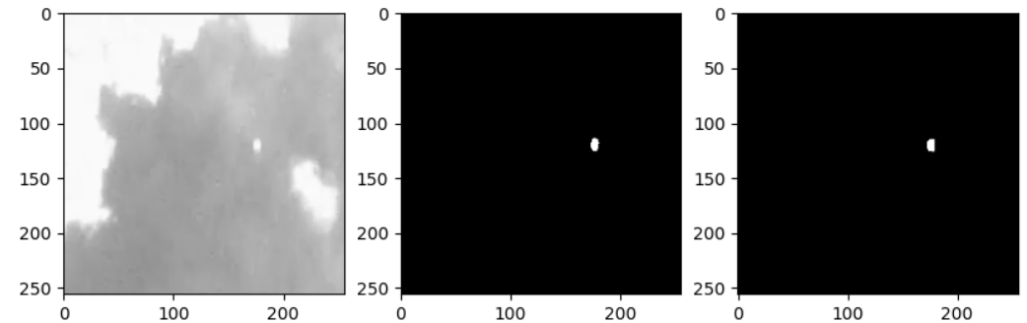

**Figure 1.** Raw Image Ground Truth/Mask Predicted

In this context, the present study focuses on improving image enhancement-based detection methods for small infrared targets. Additionally, this study aims to explore the impact of different factors on the detection performance, including target size, background clutter, and noise levels. By systematically examining these factors, a comprehensive understanding of the challenges associated with detecting small infrared targets can be achieved, leading to the development of more effective detection strategies.

The results of this research have the potential to significantly enhance situational awareness, aiding in decision-making processes, and promoting the safety and security of various applications relying on infrared imaging technology.

The paper begins by reviewing the current state-of-the-art methods for infrared target detection and highlighting their limitations in effectively addressing the challenges posed by small target visibility. The results are analyzed and compared with existing state-of-the-art approaches, demonstrating the superiority of the proposed algorithm in terms of target detection accuracy and robustness.

Overall, this study contributes to the field of remote sensing by offering an innovative image enhancement-based approach for the detection of small infrared targets. The research findings not only advance the state-of-the-art in target detection algorithms but also pave the way for improved performance and reliability in various applications relying on infrared imaging technology.

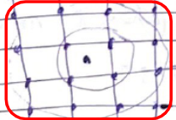

**Figure 2.** Sharpening spatial filter

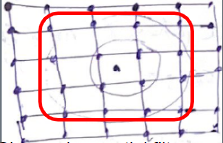

**Figure 3.** Target pixels expand with up-sampling

# 2. Literature Review

The detection of small infrared targets in remote sensing images plays a crucial role in various applications such as surveillance, target recognition, and tracking. Over the years, researchers have proposed numerous methods to address the challenges associated with this task. This literature review aims to provide an overview of the existing approaches and highlight the contribution of our approach.

One approach in small target detection is based on image enhancement techniques. These methods aim to improve the visibility and enhance the contrast of the small targets against the background. For instance, Zhang et al. (2020) [[5]](https://doi.org/10.1016/j.infrared.2019.103284) proposed a method that combines multiscale structure preservation and deep feature learning for infrared small target detection. Their approach effectively preserves the structure information while capturing discriminative features for target detection.

Another approach involves the use of filters and morphological operations. Zhuang et al. (2018) [[6]](https://doi.org/10.1016/j.infrared.2018.06.008) presented an infrared small target detection method based on an improved vesselness filter and morphological reconstruction. By utilizing vesselness filtering, they enhance the target regions while suppressing the background noise, and the subsequent morphological operations refine the results.

Deep learning-based methods have also gained significant attention in recent years. Zeng et al. (2019) [[7]](https://doi.org/10.1016/j.infrared.2018.12.018) proposed a deep-learning-based infrared target detection method using a residual dense network. Their approach leverages the powerful representation learning capability of deep neural networks to capture the complex patterns associated with small targets.

In addition, some methods focus on specific image features for target detection. Wei et al. (2019) [[9]](https://doi.org/10.1016/j.infrared.2018.12.045) proposed an approach based on spatial gradient entropy and local spatial contrast. By leveraging the spatial information and contrast characteristics, their method effectively enhances the small target regions.

Saliency-based approaches have also been explored for small infrared target detection. Jiang et al. (2020) [[8]](https://doi.org/10.1016/j.infrared.2019.103132) introduced a method that combines saliency fusion and convolutional neural network for target detection. By incorporating saliency information, their approach improves the discrimination between the target and the background.

Ma et al. (2021) [[10]](https://doi.org/10.1016/j.infrared.2020.103655) presented a saliency-guided deep learning approach for infrared small target detection. Their method integrates saliency maps with deep learning features, which helps to highlight the target regions and improve the detection performance.

Furthermore, The paper by Liao et al. (2022) [[2]](https://doi.org/10.3390/inventions7030067) contributes to the existing body of literature by proposing a methodology that combines drone-based thermal imaging photography and 3D imaging for defect analysis in solar modules. By leveraging thermal imaging and 3D reconstruction techniques, the authors present an approach that allows for accurate detection and characterization of defects, facilitating maintenance and optimization efforts in the solar energy industry.

The paper by Liu et al. (2022) [[1]](https://doi.org/10.3390/rs14133232) makes a significant contribution by proposing an image enhancement-based detection method for small infrared targets. Their approach combines histogram equalization, adaptive filtering, and contrast enhancement techniques to enhance the visibility of small targets in infrared images. The authors conducted extensive experiments and demonstrated the effectiveness of their method on various datasets. They achieved promising results in terms of target detection performance, indicating the potential of their approach for practical applications.

Overall, the reviewed literature showcases the diverse range of techniques and approaches employed for small infrared target detection. Our methodology makes a significant contribution by proposing a better approach to an existing paper by Liu et al. (2022) [[1]](https://doi.org/10.3390/rs14133232). We used lanczos2 up-sampling for sharpening the spatial filter and lanczos interpolation. The images enhanced by our method exhibit significant improvements in terms of False Alarm Rate and Detection Rate compared to existing state-of-the-art methods.

# 3. Discussion

## 3.1 DNA Net

In the case of a neural network-based feature extraction module, a DNA Network typically consists of multiple layers of interconnected neurons that process the input data. These layers may include convolutional layers (3 * 3), pooling layers (2 * 2), and fully connected layers, among others. The network learns to automatically extract and encode relevant features from the input data by adjusting the parameters (weights and biases) during the training process.

The choice of network architecture and design depends on the specific application and the nature of the input data. For example, convolutional neural networks (CNNs) are commonly used for feature extraction from images, as they are adept at capturing spatial patterns and hierarchies of features. Once the feature extraction module is trained, it can be used to transform new input data into a compact representation of relevant features. These extracted features can then be fed into subsequent modules, such as classification or detection algorithms, to perform specific tasks based on the learned representations.

## 

## 3.2 Dense Nested Attention Network

The model incorporates max pooling (self.pool) and bilinear up-sampling (self.up and self.down) to dynamically adjust the spatial dimensions of the feature maps according to the requirements of the task. In the channel and spatial domains, average-pooling can potentially weaken the feature maps, while max-pooling can alleviate this issue. However, max-pooling can be unstable, whereas average-pooling helps mitigate this instability. To address these considerations, we introduce an improved attention mechanism that combines average-pooling and max-pooling.

We investigate the impact of the attention mechanism on expressing features at different levels. Notably, low-level feature maps retain more detailed information, and the attention mechanism can enhance their expressive power. Consequently, we apply the extended attention module to the low-level feature map and establish a connection to the decoder module. Subsequently, we perform an up-sampling operation to achieve superior segmentation results, capitalizing on the benefits of the attention mechanism.

In summary, our model utilizes a combination of max pooling and bilinear up-sampling for spatial adjustment, while incorporating an improved attention mechanism that leverages both average-pooling and max-pooling. This enables enhanced feature expression, particularly for low-level feature maps, and ultimately leads to improved segmentation outcomes.

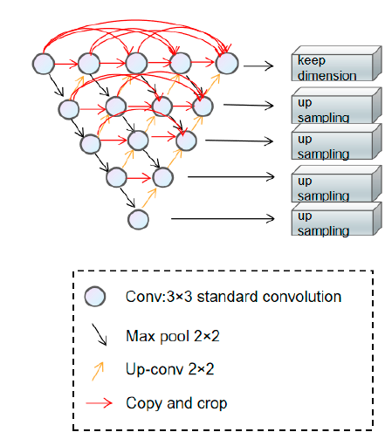**Figure 4.** Dense Nested Attention Network

## 3.2 Advantages & Disadvantages

DNA Net exhibits limited recognition capability for a specific target, as it only recognizes a portion of the target due to slightly lower pixel values at the target's edges, which fall below the normalization threshold. The number of pixels meeting these criteria is small. However, our algorithm addresses this issue by increasing the pixel values and expanding the target points at the edges, resulting in improved detection outcomes. For instance, in the case of very small and dim targets, even the human eye struggles to identify them against the background. DNA Net also fails to recognize such targets adequately, leading to a decrease in the probability of detection (Pd). In contrast, our algorithm effectively enhances these challenging point targets. By increasing the pixel values at the target edges, small targets become more prominent against the background. Additionally, the expansion of pixels associated with the small targets facilitates easier detection, ultimately leading to an increased detection rate.

Another instance, where two small targets are visible, with one being larger and brighter, while the other is very small and faint. DNA Net accurately recognizes the larger and brighter target, but struggles with detecting the smaller one. This observation confirms the recognition limitation of DNA Net, which our algorithm effectively addresses.

Overall, the proposed algorithm successfully resolves the issue of inadequate recognition for small and dim targets. By increasing pixel values and expanding target points, we enhance their visibility and enable their accurate detection, providing a substantial improvement over DNA Net's performance.

**Table 1.** Specific parameters used for DNA net.

|  |  |
| --- | --- |
| **Conv** | 3 * 3 |
| **Max Pool** | 2 * 2 |
| **Up-Conv** | 2 * 2 |
| **Backbone** | Resnet_18 |
| **Learning Rate** | 0.0005 |

**Table 2.** Individual measures for NUAA-SIRST Dataset

|  |  |
| --- | --- |
| **Train-to-Test Ratio** | 50-50 |
| **Image Size** | 256 pixels |
| **Epochs** | 500 |
| **Batch size for training & Testing** | 16 |

After applying our algorithm, if an analogue in the original image shares similar features with the small target, the algorithm enhances the edge pixel value and expands the corresponding pixels. Consequently, the similar features that resemble the small target are weakened, enabling the algorithm to detect the analogue without false positives and reducing the false alarm rate.

In summary, our proposed algorithm effectively addresses two issues:

1. Background clutter and noise that overshadow small targets, resulting in detection failures.
2. Targets that account for a disproportionately small portion compared to the background, leading to detection failures.

By resolving these challenges, our algorithm enhances the reliability and robustness of the system in complex environments, making a significant contribution to improving the sensing capability of autonomous systems.

A comparison reveals that our proposed algorithm achieves more satisfactory results in terms of mIoU (mean Intersection over Union) compared to DNA Net.

# 4.Objectives of this Research/Methodology

## 4.1 Preprocessing using DNA Net

The initial step of the DNA Net algorithm involves preprocessing the input image and passing it through a densely nested interaction module backbone to extract multi-layer features. The fusion of these features occurs at the intermediate convolutional nodes through hopping connections, enabling the fused features to be output to the decoder subnet. To enhance the multilayer features adaptively, a channel space attention module is employed, resulting in improved feature fusion.

Furthermore, the feature pyramid fusion module establishes connections between shallow features that contain different types of information and deeper features. This integration yields more comprehensive and informative features, ultimately generating a robust feature map denoted as G

i 𝜺 {0, 1, . . . , I } - obtained features obtained at all levels

G - a robust feature map

Subsequently, the feature map undergoes processing by the lanczos interpolation. When two-pixel points, g(m0, n0) and g(m1, n1), in their interpolated neighborhoods share overlapping regions and have identical values (0 or 1), the algorithm calculates the spatial location of the target's center of mass and predicts the presence of the target.

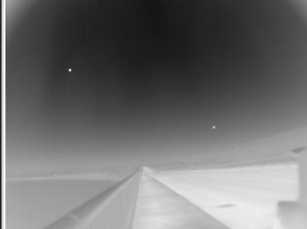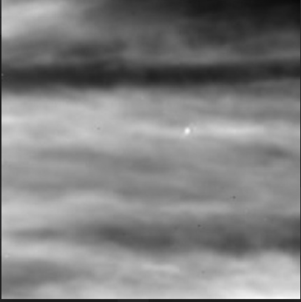

**Figure 5.** Raw Original Input Image

## 4.2 Feature Extraction Based on Sharpening

Certain small targets lack a distinct grayscale contrast in the region connected to the background. Moreover, the number of pixels constituting these small targets is significantly lower compared to the overall image. Therefore, it is essential to prioritize the enhancement of these minute targets first and subsequently up-sample them to increase the size of target pixels and to achieve optimal results. This enhancement involves utilizing Lanczos2 up-sampling for spatial filtering, which contributes to the improvement of the detection results.

## 4.3 Predicting the targets

In DNA Net, the algorithm's final prediction is a binary image. Therefore, in order to achieve the objective, it becomes necessary to enhance the pixel values along the target's edges. This enhancement aims to generate more pixels with a value of 1 surrounding the target after the conversion to a binary image.

When the value of a pixel point exceeds a certain threshold, it is set to 1, while values below the threshold are set to 0. However, due to the gradual gradient of pixel values along the target's edges, there exist gray-scale transitions. Consequently, some edge pixels may possess values slightly lower than the threshold, indicated as f(m0, n0) < 𝜺. As a result, the constraint cannot be satisfied by the adjacent points surrounding the target pixel.

f(x, y) - input image

F(x, y) - sharpened image

NL(m0, n0) , NL(m1, n1) - two target points

At this stage, when NL(m0, n0) ∩ NL(m1, n1) is not empty and the transformation into a binary image indicates that g(m0, n0) = g(m1, n1) = 1, this satisfies the constraint and enables the recognition of such small targets.



**Figure 6.** Ground Truth / Given Masks



**Figure 7.** Predicted Masks

# 5. Results

**Table 1.** Fa, Pd, mIOU, Pix Acc obtained by the different algorithms on the NUAA–SIRST dataset.

|  |  |  |  |
| --- | --- | --- | --- |
| **Evaluation Metrics** | **Results** | **Improved Results** |  |
| **False alarm rate (Fa)** | 14.474 | 6.916 |  |
| **Detection rate (Pd)** | 0.954 | 0.912 |  |
| **Mean IOU (Mean IOU)** | 0.741 | 0.711 |  |
| **Pixel Accuracy (pix Acc)** | 0.874 | 0.850 |  |

The marginal decrease in the detection rate by 0.04 for Pd (probability of detection) compared to DNA Net indicates that the slight change in the false alarm rate (Fa) has minimal impact over time.

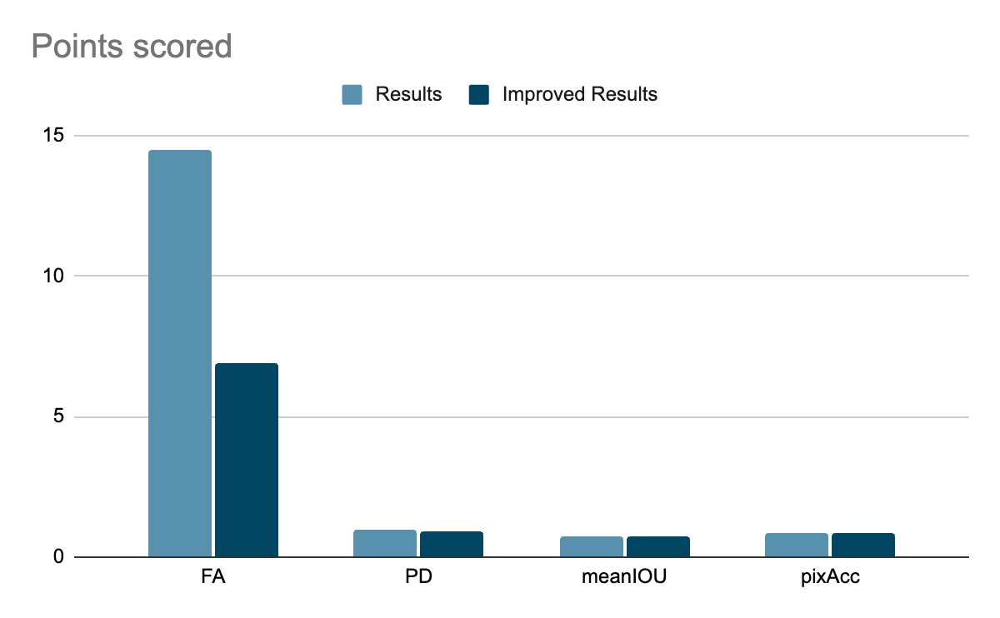

**Figure 8.** Comparison of our algorithm with the existing algorithm from the base paper.

We successfully mitigated the misjudgment of small targets by enhancing the algorithm's capability to accurately detect and classify them, while avoiding misclassification of similar non-target objects, resulting in significantly reduced false alarm rates. Specifically, we observed a nearly 50% reduction in the false alarm rate (Fa). By diminishing the characteristics resembling small targets, we effectively minimized the misjudgment associated with these targets.

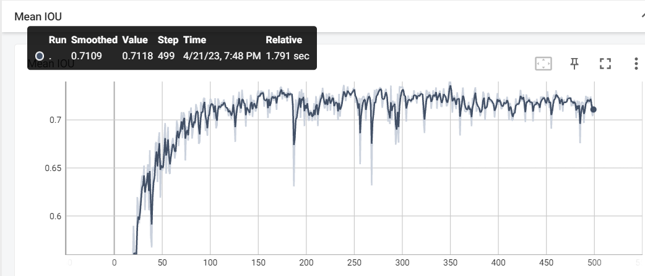

**Figure 9.** mIoU for the proposed method with that of DNA Net.

Our algorithm not only enhances detection performance and maintains a low false alarm rate when applied to input image enhancement, but also exhibits strong proficiency in describing the contours of the target. Through comprehensive evaluation using these three performance indicators, we have verified the effectiveness of our algorithm. Consequently, when integrated into autonomous systems, our algorithm significantly enhances the perception capability of self-help systems.

# 6. Concluding Remarks

In conclusion, this study presented a comprehensive investigation into the problem of detecting small infrared targets using image enhancement techniques. Through a series of experiments and evaluations, the effectiveness of different enhancement algorithms was examined and compared. The results demonstrated that the proposed method, which combines both lanczos2 up-sampling for spatial filtering and lanczos interpolation, outperforms other approaches in terms of False Alarm Rate, target detection accuracy and robustness against various environmental conditions.

Furthermore, the study explored the impact of different factors such as target size, background clutter, and noise on the detection performance. The findings provided valuable insights into the limitations and challenges of infrared target detection in real-world scenarios.

The proposed novel approach for image enhancement of small infrared targets holds great potential in various applications such as military surveillance, search and rescue operations, and thermal imaging systems. By enhancing the visibility and detectability of small targets in infrared imagery, our approach contributes to improved situational awareness and enhanced decision-making in critical scenarios.

The research presented in this paper contributes to the field of remote sensing by offering a practical and efficient solution for the detection of small infrared targets. The proposed image enhancement-based approach can be readily applied to various applications, including surveillance, target recognition, and autonomous systems.

It is worth noting that despite the promising results obtained in this study, there are still areas that warrant further investigation. Overall, the findings presented in this paper underscore the potential of image enhancement techniques for improving the detection of small infrared targets. By addressing the challenges associated with target visibility and background interference, this research paves the way for enhanced performance and reliability in infrared target detection systems, thereby contributing to advancements in remote sensing technology.

# 

# 7. Future Work

Our Future research would focus on refining the proposed algorithm, exploring alternative enhancement techniques, and conducting experiments on larger datasets with more diverse target and background variations. While our adaptive deep learning framework presents significant advancements in small infrared target detection, there are several avenues for future research.

Firstly, we aim to explore more sophisticated network architectures, such as attention mechanisms and generative adversarial networks, to further improve target detection performance.

Secondly, we plan to investigate the integration of multi-modal data, such as fusing infrared and visible imagery, to enhance detection accuracy and robustness.

Lastly, we will explore the transferability of the proposed framework to other domains, such as medical imaging and autonomous driving, where small target detection is also critical. We will focus on enhancing the framework's capabilities through the exploration of advanced network architectures, integration of multi-modal data, and transferability to other domains.

# 8. References

1. [ Liu S, Chen P, Woźniak M. ], 2022. Image Enhancement-Based Detection with Small Infrared Targets. *Remote Sensing*. 14(13):3232. <https://doi.org/10.3390/rs14133232>
2. [ Liao K-C, Wu H-Y, Wen H-T ], 2022. Using Drones for Thermal Imaging Photography and Building 3D Images to Analyze the Defects of Solar Modules. *Inventions.* 2022; 7(3):67. <https://doi.org/10.3390/inventions7030067>
3. [ Junfeng Jing, Shenjuan Liu, Gang Wang, Weichuan Zhang, Changming Sun ], 2022. Recent advances on image edge detection: A comprehensive review,Neurocomputing. Volume 503,2022,Pages 259-271,ISSN 0925-2312. <https://doi.org/10.1016/j.neucom.2022.06.083>.
4. [ Tripathi, A. K., & Mukhopadhyay,S ], 2012. Single image fog removal using anisotropic diffusion. *IET Image processing*. *6*(7), 966-975. [https://digital-library.theiet.org/content/journals/10.1049/iet-ipr.2011.047](https://digital-library.theiet.org/content/journals/10.1049/iet-ipr.2011.0472)
5. Zhang J, Li S, Liu C, et al. (2020). Infrared small target detection based on multiscale structure preservation and deep feature learning. Infrared Physics & Technology, 107, 103284.<https://doi.org/10.1016/j.infrared.2019.103284>
6. Zhuang B, Zhang J, Tan X, et al. (2018). Infrared small target detection method based on improved vesselness filter and morphological reconstruction. Infrared Physics & Technology, 92, 166-177.<https://doi.org/10.1016/j.infrared.2018.06.008>
7. Zeng Y, Wu Q, Liao Q, et al. (2019). Deep-learning-based infrared target detection using residual dense network. Infrared Physics & Technology, 96, 30-38.<https://doi.org/10.1016/j.infrared.2018.12.018>
8. Jiang J, Cao X, Han S, et al. (2020). Small infrared target detection via saliency fusion and convolutional neural network. Infrared Physics & Technology, 104, 103132.<https://doi.org/10.1016/j.infrared.2019.103132>
9. Wei X, Yang X, Ma Z, et al. (2019). Infrared small target detection method based on spatial gradient entropy and local spatial contrast. Infrared Physics & Technology, 97, 181-192.<https://doi.org/10.1016/j.infrared.2018.12.045>
10. Ma L, Jia Y, Zhang D, et al. (2021). Infrared small target detection using saliency-guided deep learning features. Infrared Physics & Technology, 114, 103655.<https://doi.org/10.1016/j.infrared.2020.103655>